Zadania choinkowe – choinka, Mikołaj, prezent

**Autor:** Mateusz Laskowski

Obliczenia wykonałem w programach MatLab oraz Mathematica.

Wykresy stworzyłem w programie Mathematica.

**Choinka:**

Macierz 12x12

|  |  |  |  |  |  |  |  |  |  |  |  |
| --- | --- | --- | --- | --- | --- | --- | --- | --- | --- | --- | --- |
|  |  |  |  |  |  |  |  |  |  |  |  |
|  |  |  |  |  | X |  |  |  |  |  |  |
|  |  |  |  | x | x | X |  |  |  |  |  |
|  |  |  |  |  | X |  |  |  |  |  |  |
|  |  |  | x | x | X | x | x |  |  |  |  |
|  |  |  |  |  | x |  |  |  |  |  |  |
|  |  | x | x | x | x | x | x | X |  |  |  |
|  |  |  |  |  | x |  |  |  |  |  |  |
|  | x | x | x | x | x | x | x | x | x |  |  |
|  |  |  |  |  | x |  |  |  |  |  |  |
| X | x | x | x | x | x | x | x | x | x | x |  |
|  |  |  |  |  | x |  |  |  |  |  |  |

|  |  |  |  |  |  |  |  |  |  |  |  |
| --- | --- | --- | --- | --- | --- | --- | --- | --- | --- | --- | --- |
| 0 | 0 | 0 | 0 | 0 | 0 | 0 | 0 | 0 | 0 | 0 | 0 |
| 0 | 0 | 0 | 0 | 0 | 1 | 0 | 0 | 0 | 0 | 0 | 0 |
| 0 | 0 | 0 | 0 | 1 | 1 | 1 | 0 | 0 | 0 | 0 | 0 |
| 0 | 0 | 0 | 0 | 0 | 1 | 0 | 0 | 0 | 0 | 0 | 0 |
| 0 | 0 | 0 | 1 | 1 | 1 | 1 | 1 | 0 | 0 | 0 | 0 |
| 0 | 0 | 0 | 0 | 0 | 1 | 0 | 0 | 0 | 0 | 0 | 0 |
| 0 | 0 | 1 | 1 | 1 | 1 | 1 | 1 | 1 | 0 | 0 | 0 |
| 0 | 0 | 0 | 0 | 0 | 1 | 0 | 0 | 0 | 0 | 0 | 0 |
| 0 | 1 | 1 | 1 | 1 | 1 | 1 | 1 | 1 | 1 | 0 | 0 |
| 0 | 0 | 0 | 0 | 0 | 1 | 0 | 0 | 0 | 0 | 0 | 0 |
| 1 | 1 | 1 | 1 | 1 | 1 | 1 | 1 | 1 | 1 | 1 | 0 |
| 0 | 0 | 0 | 0 | 0 | 1 | 0 | 0 | 0 | 0 | 0 | 0 |

Wszystkie wartości własne macierzy:

w1 =1.0000

w2 = 3.0000

w3 = 0.0000

w4 =0.0000

w5 = 0.0000

w6 =0

w7 =0

w8 =0

w9 =0

w10 =0

w11 =0

w12 =1.0000

Dwie największe wartości własne i ich wektory:

x1=3

y1=

x2=1

y2=

Macierz polaczen :

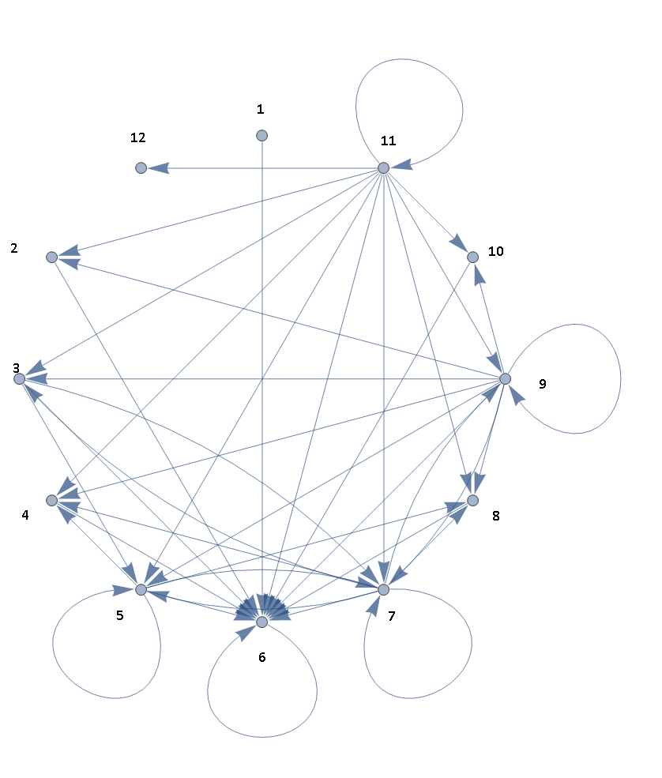

**Mikołaj:**

|  |  |  |  |  |  |  |  |  |  |  |  |
| --- | --- | --- | --- | --- | --- | --- | --- | --- | --- | --- | --- |
| X |  |  |  |  | x |  |  |  |  |  |  |
| X |  |  |  | x | x | x | x |  |  |  |  |
| X |  |  | x | x | x | x | x | x |  |  |  |
| X |  |  | x | x | X | x |  | x | X |  |  |
| X |  |  | x |  |  | X |  |  | x | X |  |
| X |  |  |  | X | x |  |  |  |  | X |  |
| X | x | x | x | x | x | x | x | X |  |  |  |
| X |  |  | X | X | X | X |  |  |  |  |  |
| X |  |  | X | x | X | x |  |  |  |  |  |
| X |  |  |  | X | X |  |  |  |  |  |  |
| X |  |  |  | x | X |  |  |  |  |  |  |
|  |  |  | x | X | x | x |  |  |  |  |  |

|  |  |  |  |  |  |  |  |  |  |  |  |
| --- | --- | --- | --- | --- | --- | --- | --- | --- | --- | --- | --- |
| 1 | 0 | 0 | 0 | 0 | 1 | 0 | 0 | 0 | 0 | 0 | 0 |
| 1 | 0 | 0 | 0 | 1 | 1 | 1 | 1 | 0 | 0 | 0 | 0 |
| 1 | 0 | 0 | 1 | 1 | 1 | 1 | 1 | 1 | 0 | 0 | 0 |
| 1 | 0 | 0 | 1 | 1 | 1 | 1 | 0 | 1 | 1 | 0 | 0 |
| 1 | 0 | 0 | 1 | 0 | 0 | 1 | 0 | 0 | 1 | 1 | 0 |
| 0 | 0 | 0 | 0 | 1 | 1 | 0 | 0 | 0 | 0 | 1 | 0 |
| 1 | 1 | 1 | 1 | 1 | 1 | 1 | 1 | 1 | 0 | 0 | 0 |
| 1 | 0 | 0 | 1 | 1 | 1 | 1 | 0 | 0 | 0 | 0 | 0 |
| 1 | 0 | 0 | 1 | 1 | 1 | 1 | 0 | 0 | 0 | 0 | 0 |
| 1 | 0 | 0 | 0 | 1 | 1 | 0 | 0 | 0 | 0 | 0 | 0 |
| 1 | 0 | 0 | 0 | 1 | 1 | 0 | 0 | 0 | 0 | 0 | 0 |
| 0 | 0 | 0 | 1 | 1 | 1 | 1 | 0 | 0 | 0 | 0 | 0 |

Wszystkie wartości własne:

w1 = 0

w2 =4.5290

w3 =1.9065

w4=1.2188

w5=1.2188

w6 =1.1740

w7=0.8629

w8=0.8629

w9=0.2676

w10=0.0000

w11= 0.0000

w12 =0.0000

Dwie największe wartości własne i ich wektory:

x1= 4.5290

y1=

x2= 1.9065

y2 =

Macierz polaczen :

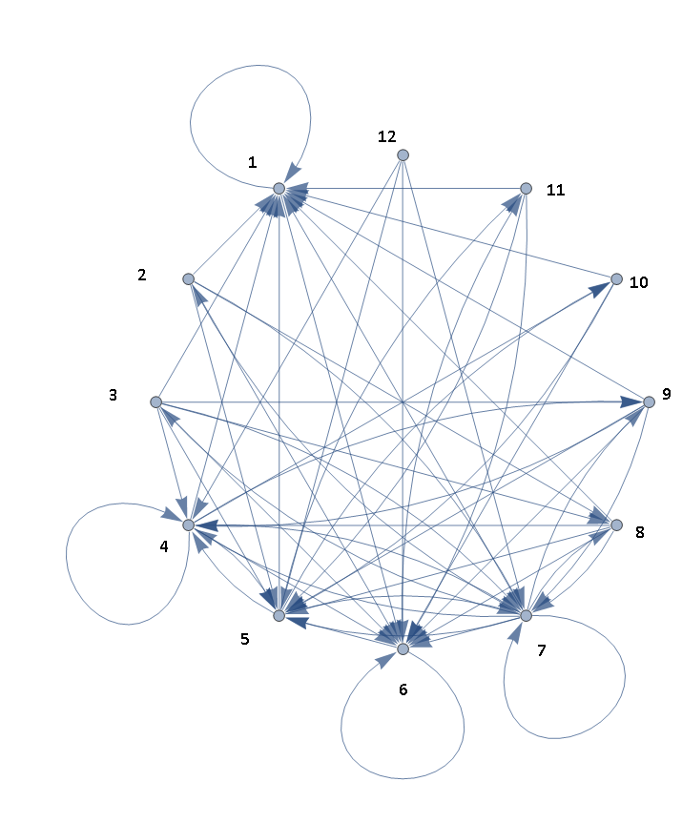

**Prezent:**

|  |  |  |  |  |  |  |  |  |  |  |  |
| --- | --- | --- | --- | --- | --- | --- | --- | --- | --- | --- | --- |
|  |  |  | x |  |  |  |  | X |  |  |  |
|  |  |  |  | x |  |  | X |  |  |  |  |
|  |  |  |  |  | x | X |  |  |  |  |  |
|  |  | X | x | x | x | X | x | x | x |  |  |
|  |  | X |  |  | X | X |  |  | X |  |  |
|  |  | X |  |  | X | X |  |  | X |  |  |
|  |  | X | x | x | X | X | x | x | X |  |  |
|  |  | X |  |  | X | X |  |  | X |  |  |
|  |  | X |  |  | x | X |  |  | X |  |  |
|  |  | x |  |  | X | X |  |  | X |  |  |
|  |  | x | x | x | x | x | x | x | X |  |  |
|  |  |  |  |  |  |  |  |  |  |  |  |

|  |  |  |  |  |  |  |  |  |  |  |  |
| --- | --- | --- | --- | --- | --- | --- | --- | --- | --- | --- | --- |
| 0 | 0 | 0 | 1 | 0 | 0 | 0 | 0 | 1 | 0 | 0 | 0 |
| 0 | 0 | 0 | 0 | 1 | 0 | 0 | 1 | 0 | 0 | 0 | 0 |
| 0 | 0 | 0 | 0 | 0 | 1 | 1 | 0 | 0 | 0 | 0 | 0 |
| 0 | 0 | 1 | 1 | 1 | 1 | 1 | 1 | 1 | 1 | 0 | 0 |
| 0 | 0 | 1 | 0 | 0 | 1 | 1 | 0 | 0 | 1 | 0 | 0 |
| 0 | 0 | 1 | 0 | 0 | 1 | 1 | 0 | 0 | 1 | 0 | 0 |
| 0 | 0 | 1 | 1 | 1 | 1 | 1 | 1 | 1 | 1 | 0 | 0 |
| 0 | 0 | 1 | 0 | 0 | 1 | 1 | 1 | 1 | 1 | 0 | 0 |
| 0 | 0 | 1 | 0 | 0 | 1 | 1 | 0 | 0 | 1 | 0 | 0 |
| 0 | 0 | 1 | 0 | 0 | 1 | 1 | 0 | 0 | 1 | 0 | 0 |
| 0 | 0 | 1 | 1 | 1 | 1 | 1 | 1 | 1 | 1 | 0 | 0 |
| 0 | 0 | 0 | 0 | 0 | 0 | 0 | 0 | 0 | 0 | 0 | 0 |

Wszystkie wartości własne:

w1= 0

w2= 6.2426

w3= 0.0000

w4= 2.2426

w5= 0.0000

w6= 0.0000

w7= 0.0000

w8= 0.0000

w9= 0.0000

w10= 0

w11= 0

w12= 0

Dwie największe wartości własne i ich wektory:

x1=6.2426

y1=

x2= 2.2426

y2=

Macierz polaczen :

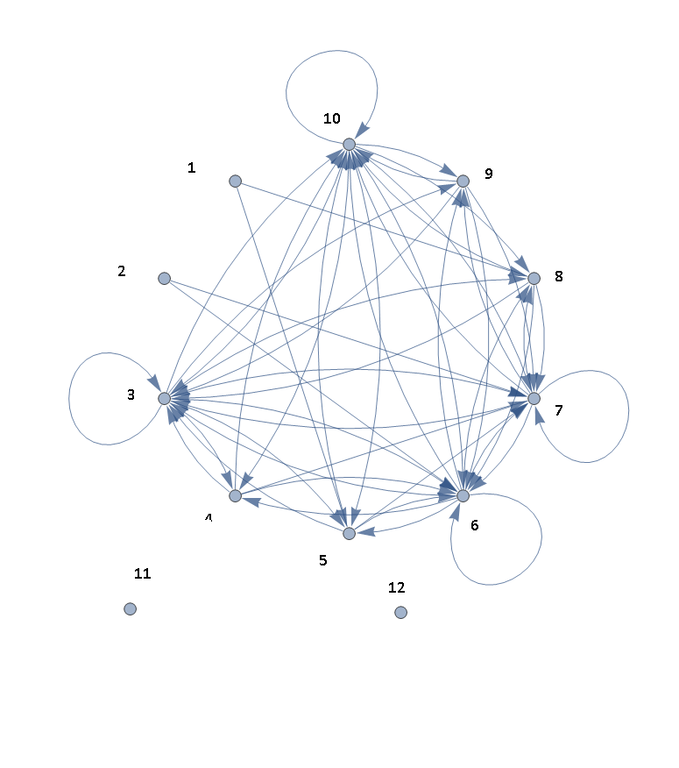

Widmo wartości własnych macierzy Mikolaj, Choinka, Prezent

Wartosci sa zaznaczone w ten sposób, by nie zamazać wykresu

